State Machines and the LCD Display
Module | ET4047
Date | 28/10/2026
Lab No. | Lab 6
Author | Luke Griffin

1 Task 1: A traffic light on the LCD
Objective: run a three-state traffic light (RED → GREEN → YELLOW) and change the state machine.

Wiring
I2C LCD connections (used in every task)
From |  | To | Purpose
LCD GND | → | Nano GND | Ground
LCD VCC | → | Nano 5V | Power
LCD SDA | → | Nano A4 | I2C data
LCD SCL | → | Nano A5 | I2C clock

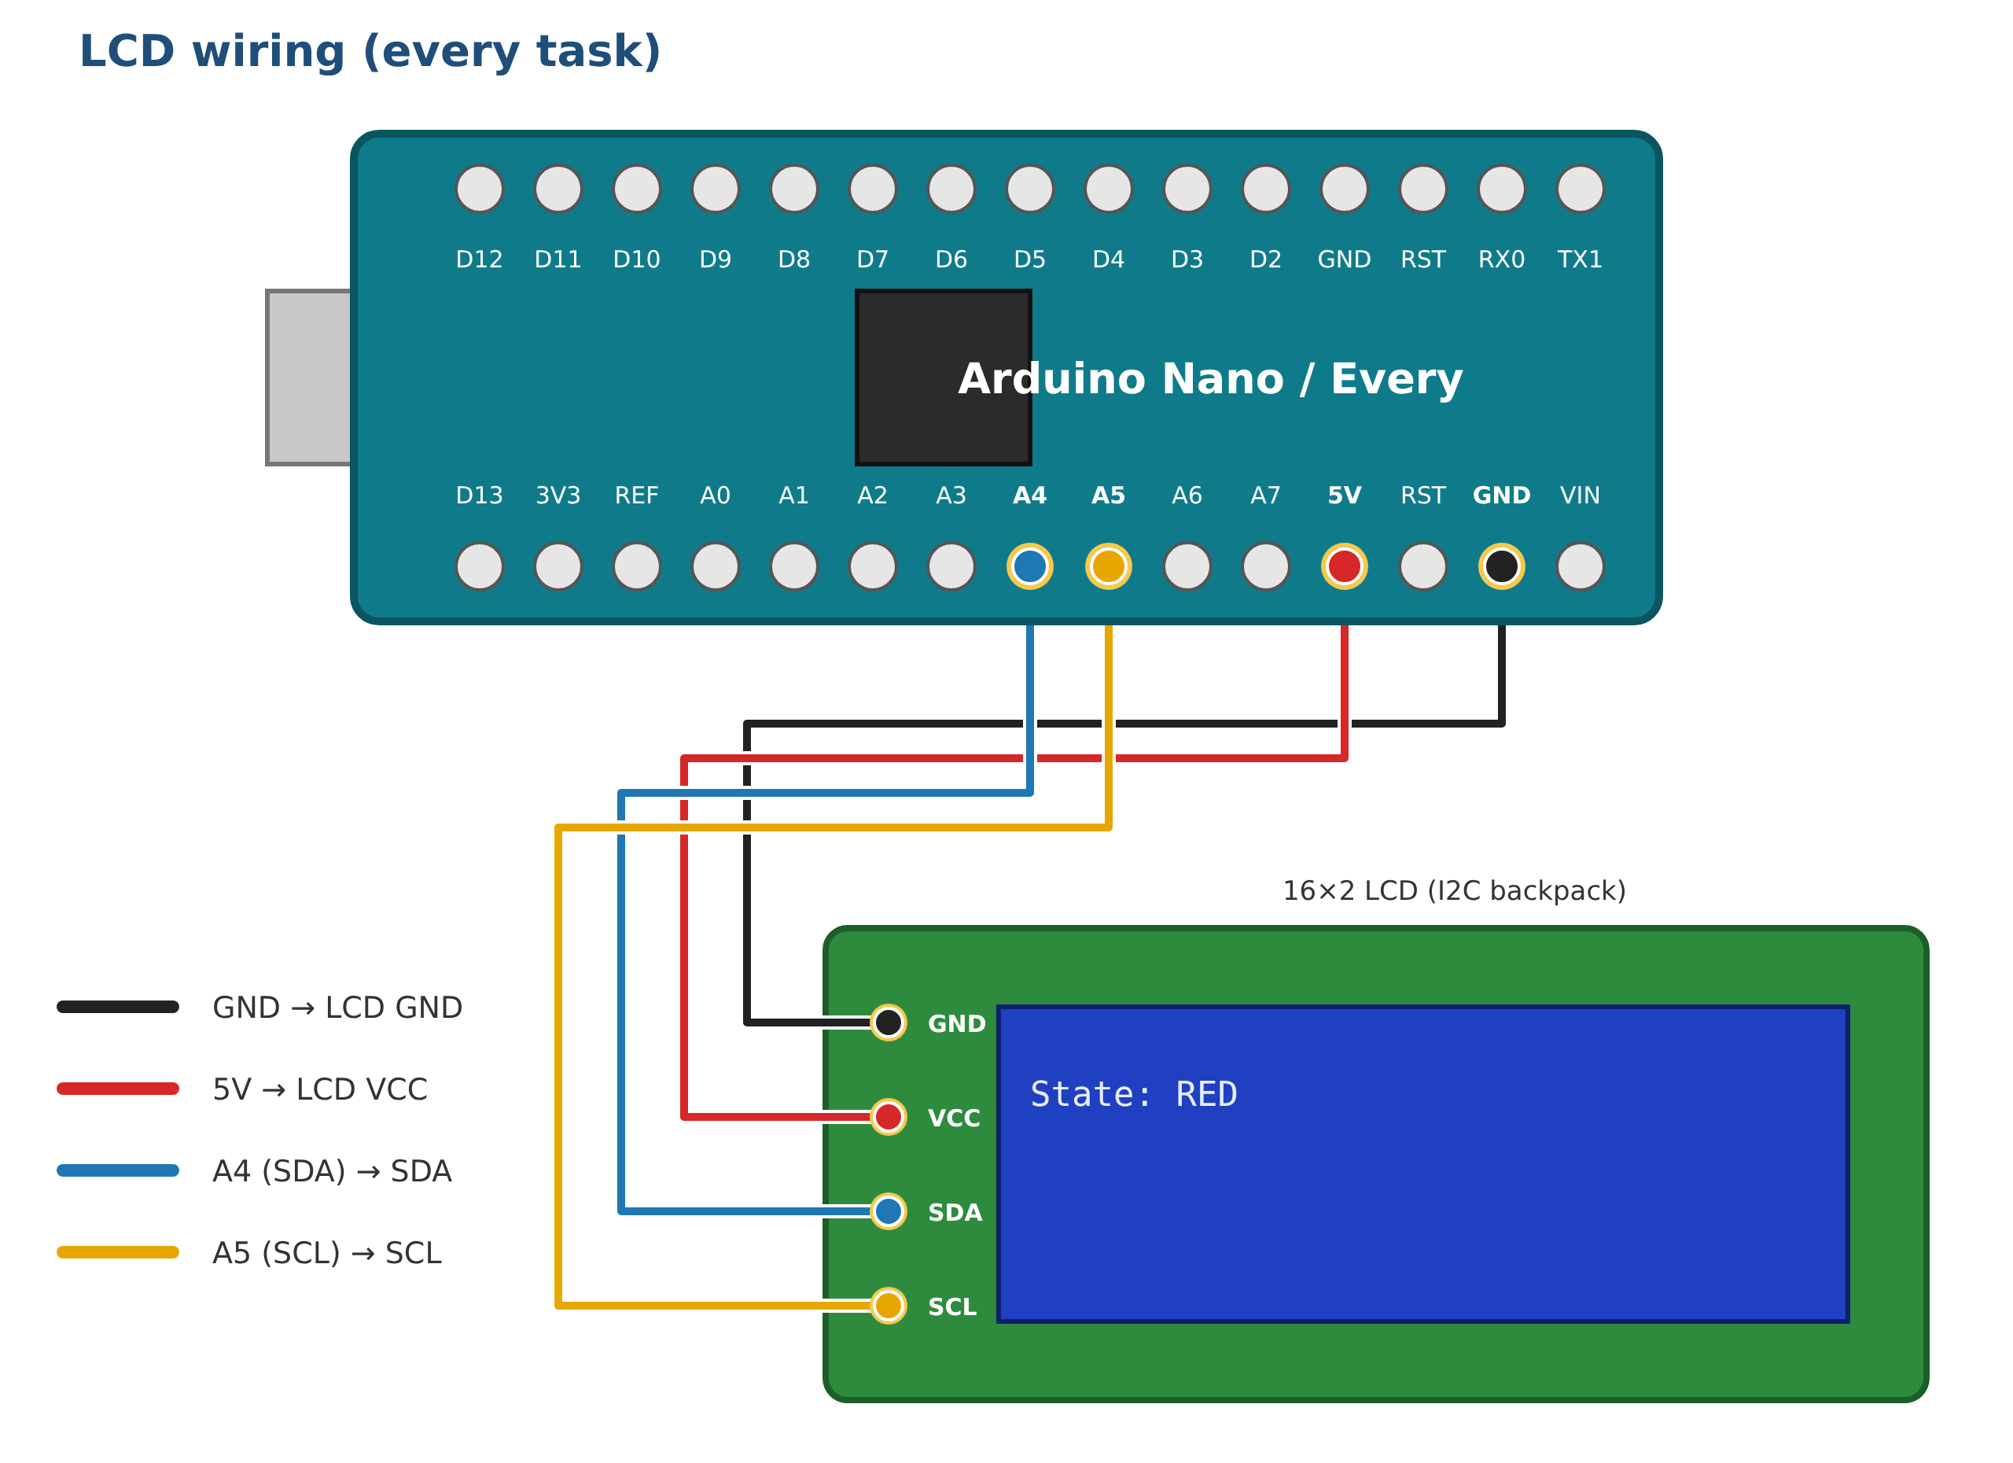
Figure 1: LCD wiring. The RGB LCD shield needs no wires: plug it onto the breakout board.

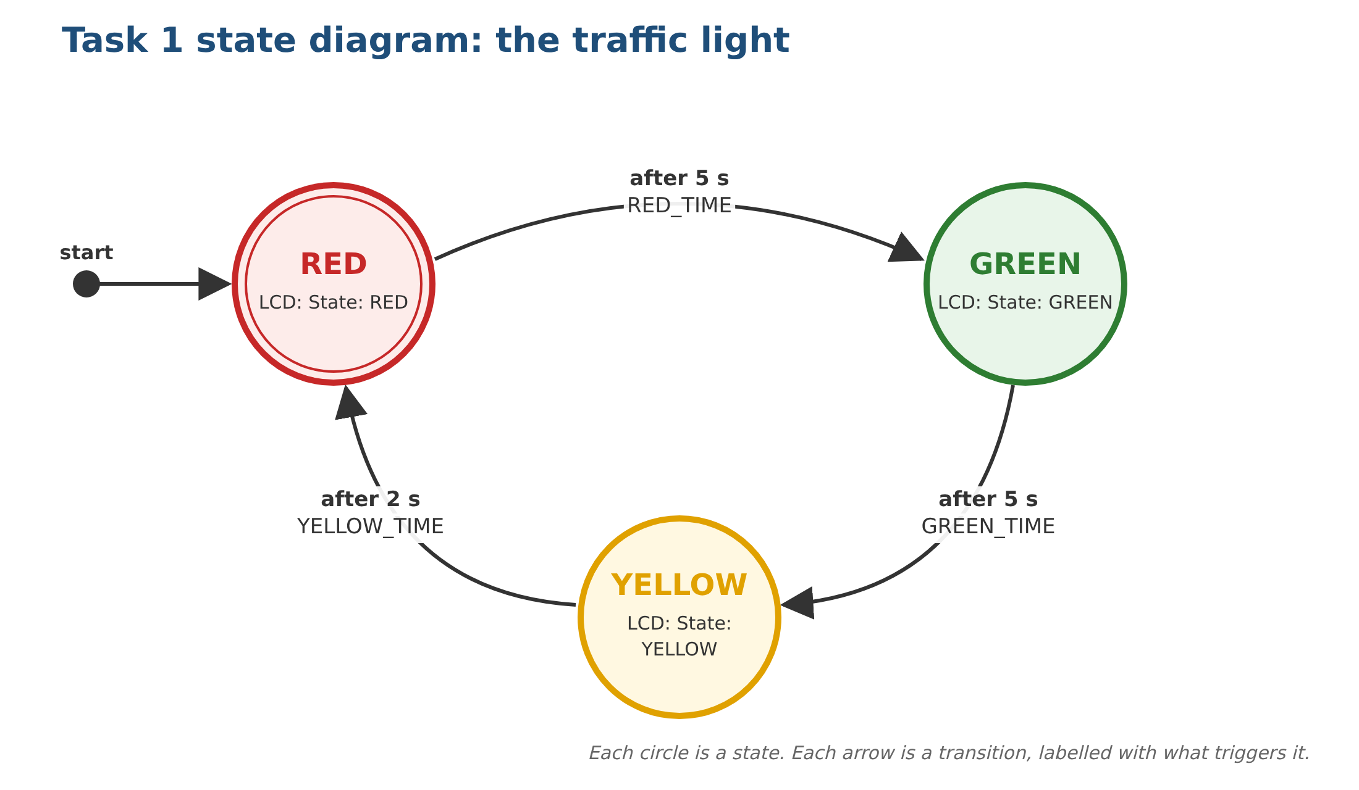
Figure 2: Task 1 state diagram

Code
Upload Task1_Traffic_Light. Use the folder for your display: I2C_Backpack_LCD (separate screen with four wires) or Adafruit_RGB_LCD_Shield (plugs on, five buttons).

Expected result: the LCD shows State: RED for 5 s, State: GREEN for 5 s, State: YELLOW for 2 s, and repeats.

Task 1 questions

1a Run it
Upload the code and check the states change in the right order. (record) Take a photo of the LCD.

1b The transition table
Fill in the table from the code.
Current state | Time in state | Next state | LCD shows
RED
GREEN
YELLOW

How long does one full cycle take?
Your answer:

1c Change the timing
Make YELLOW last 3 seconds instead of 2. Which line did you change? Why is it better to keep the times in named constants such as YELLOW_TIME than to type delay(2000) inside the case?
Your answer:

1d Add a state
Add a fourth state, RED_AMBER, which shows State: RED+AMBER for 2 s, so the cycle becomes RED → RED_AMBER → GREEN → YELLOW → RED. Which three places in the code did you change? (record) Draw your new state diagram.
Your answer:

2 Task 2: Traffic light with real LEDs
Objective: drive a red, a yellow and a green LED from the state machine, with exactly one LED on at a time.

Wiring
LED connections (keep the LCD wiring from Task 1)
From |  | To | Purpose
Nano D5 | → | 220 Ω → red LED long leg | Red light
Nano D6 | → | 220 Ω → yellow LED long leg | Yellow light
Nano D7 | → | 220 Ω → green LED long leg | Green light
Each LED short leg | → | GND rail → Nano GND | Common ground

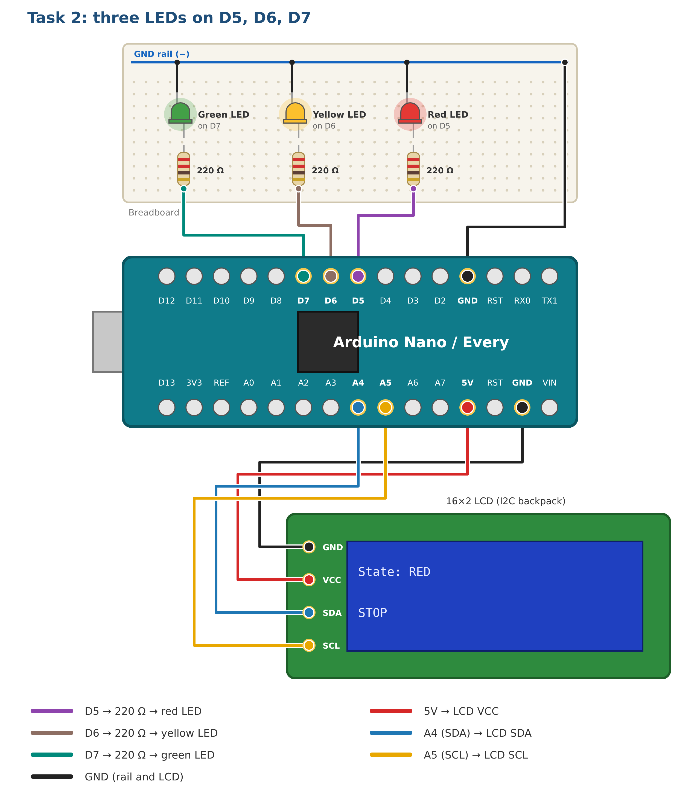
Figure 3: Task 2 wiring

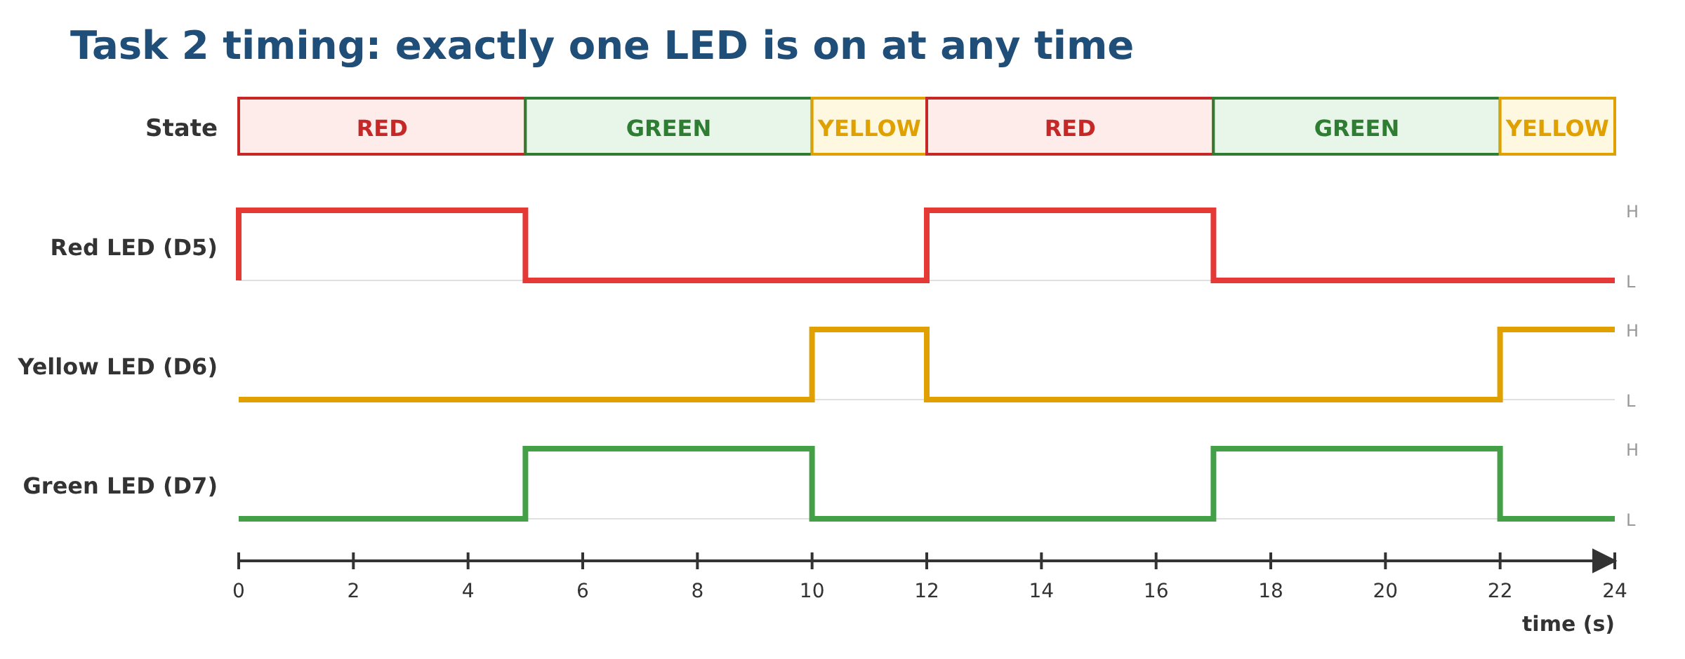
Figure 4: Task 2 LED outputs over two cycles

Code
Upload Task2_Traffic_Light_LEDs. Use the folder for your display: I2C_Backpack_LCD (separate screen with four wires) or Adafruit_RGB_LCD_Shield (plugs on, five buttons).

Expected result: one LED at a time, in step with the LCD (State: RED / STOP, and so on).

Task 2 questions

2a Run it
(record) Paste a few lines from the Serial Monitor. They should look like this:
Serial Monitor
Traffic light ready
State 0: RED
State 1: GREEN
State 2: YELLOW

2b Forget to switch an LED off
In each case, replace the setLights(…) line with a single digitalWrite(…, HIGH) for that state’s LED. Run it for two cycles. What do the LEDs show, and why? Compare with Figure 4. Then put setLights() back.
Your answer:

2c The numbers behind the names
What would the LCD show if you changed the enum to { RED, YELLOW, GREEN } but left the two text arrays as they are? Why?
Your answer:

2d The resistor
A red LED drops about 2 V and the pin gives 5 V. Roughly how much current flows through the 220 Ω resistor?
Your answer:

3 Task 3: A pedestrian crossing
Objective: the cars’ light stays GREEN until the button is pressed, then goes YELLOW → WALK (countdown) → CLEAR → GREEN. The sketch uses millis() instead of delay().

Wiring
Add the button (keep the LEDs and LCD from Task 2)
From |  | To | Purpose
Nano D2 | → | Push button, one leg | Pedestrian button
Push button, other leg | → | GND rail | Pressing pulls D2 to 0 V

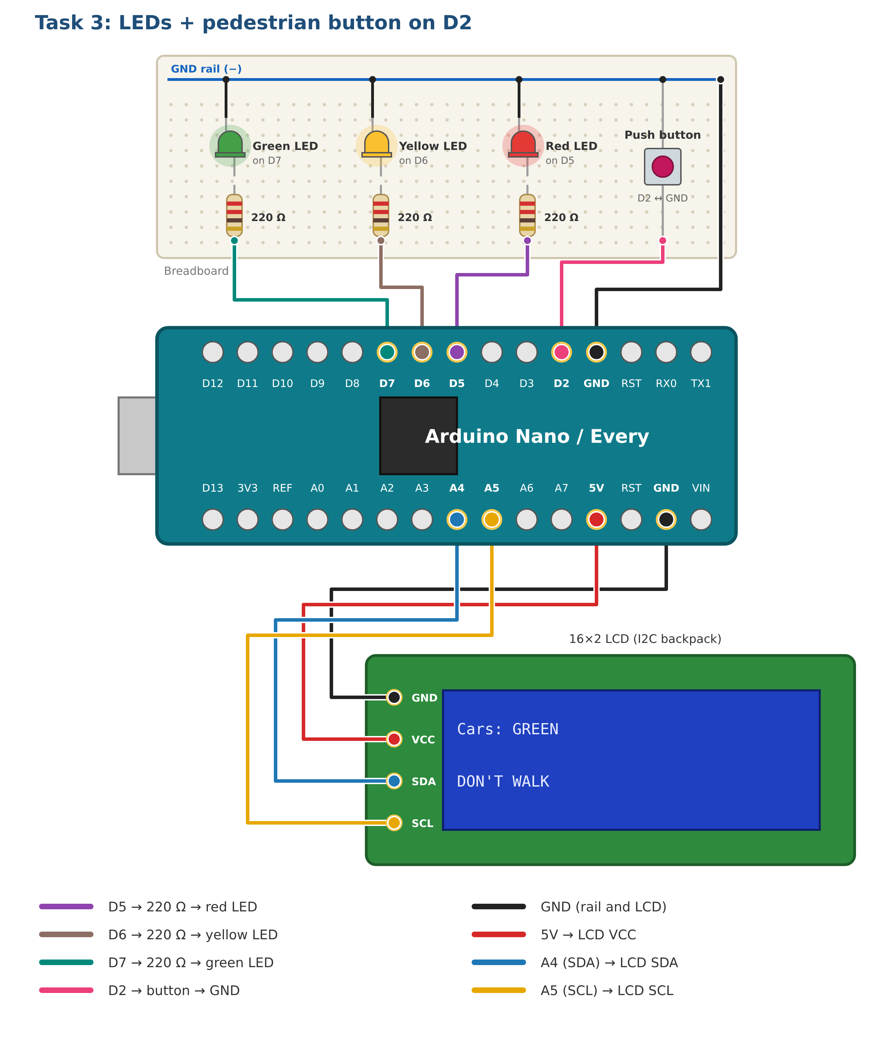
Figure 5: Task 3 wiring

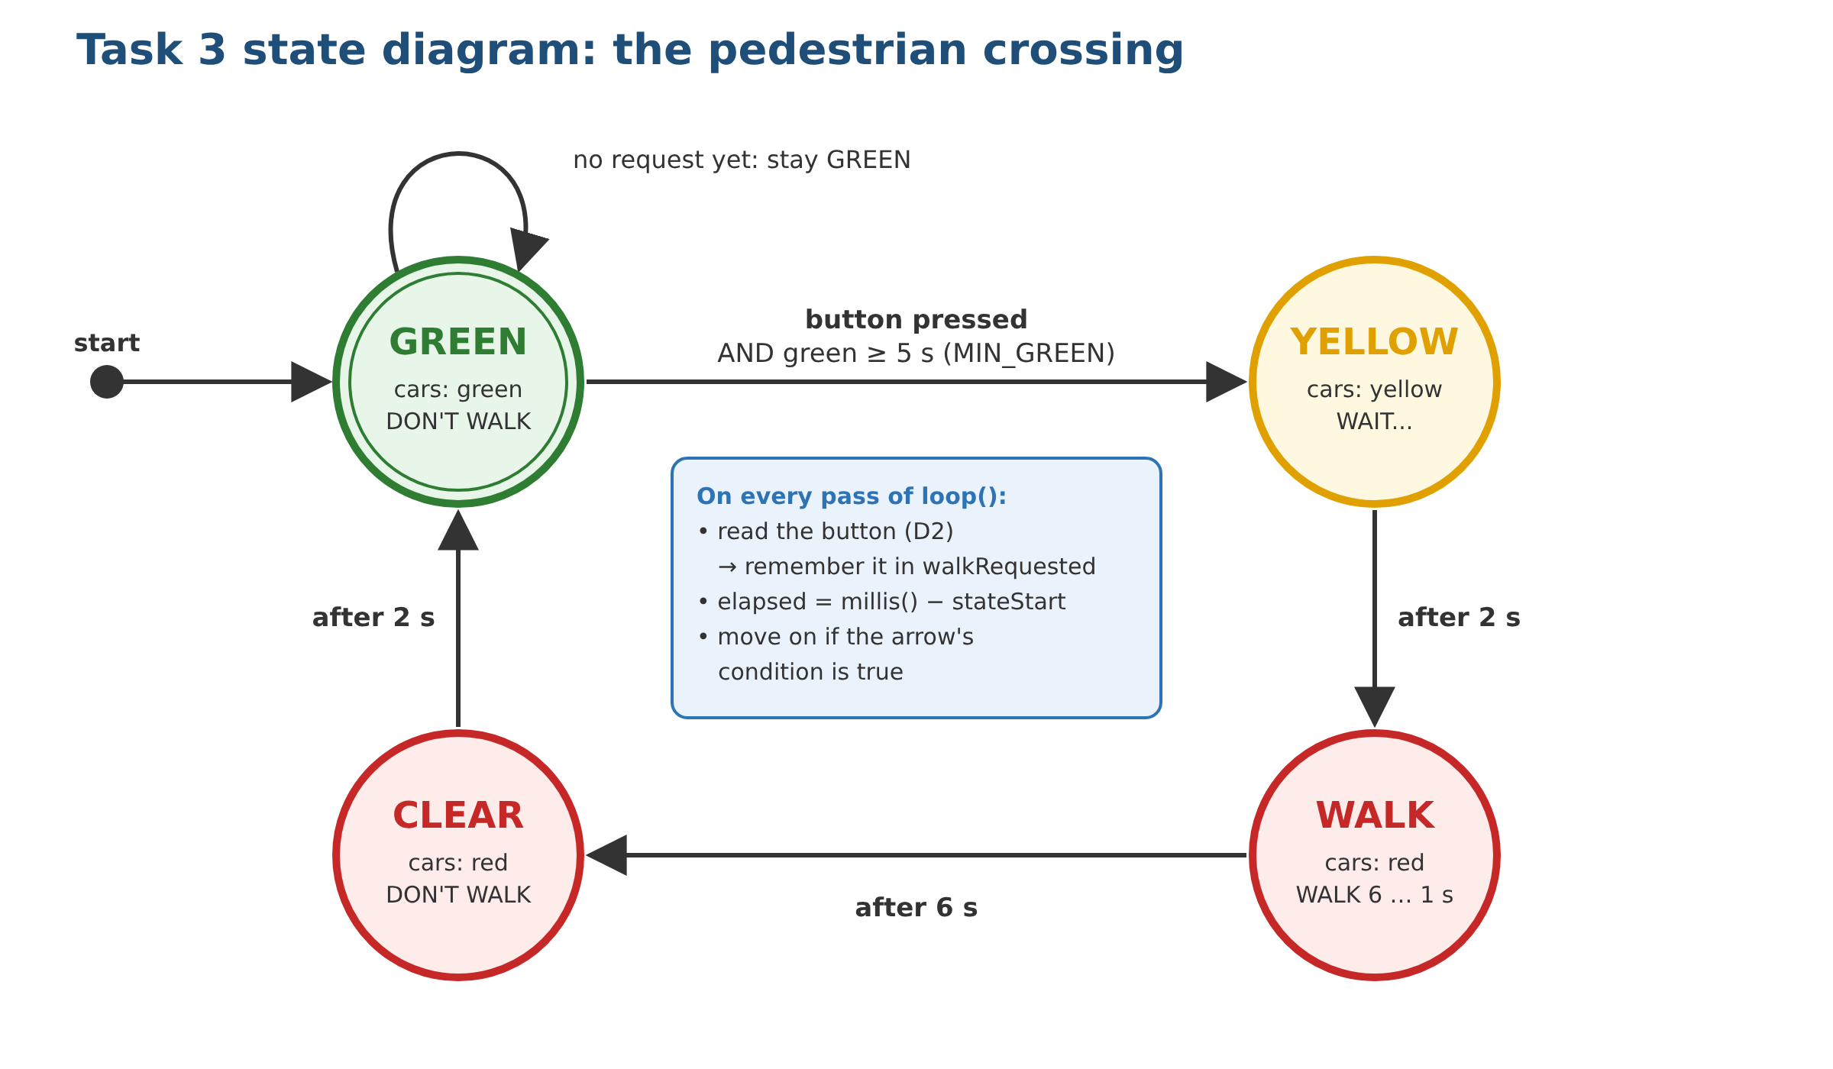
Figure 6: Task 3 state diagram

Code
Upload Task3_Pedestrian_Crossing. Use the folder for your display: I2C_Backpack_LCD (separate screen with four wires) or Adafruit_RGB_LCD_Shield (plugs on, five buttons).

Expected result: the light stays GREEN until you press the button; the LCD shows WAIT..., then a WALK 6s … 1s countdown.

Task 3 questions

3a Run it
Press the button. (record) Paste the Serial Monitor output for one crossing. It should look like this:
Serial Monitor
Crossing ready
-> GREEN
Button pressed
-> YELLOW
-> WALK
-> CLEAR
-> GREEN

3b Press it at different times
Press the button at each of the times below. Use the state diagram to explain each result.
When you press | What happens | Why
Just after the light turns GREEN
When GREEN has been on for more than 5 s
During WALK
During CLEAR

3c delay() would miss it
If Task 2 checked the button at the top of loop(), what is the longest a pedestrian might have to hold it before the board noticed? Why does Task 3 notice a tap of a few milliseconds?
Your answer:

3d No debouncing needed
One press of a mechanical button can read as several quick presses. Why does that not cause a problem here? (Hint: what does a second press do to walkRequested?)
Your answer:

